# ACTIVITIES

EXERCISE 1:

|  |  |
| --- | --- |
| Objective | Jack must sum the number on cell and paint on the dots cell.  **Your code shall work for the 2 cases!!!!** |
| Maximum number of instructions | 10 |
| Allowed instructions | IF <CONDITION> WHILE <CONDITION>  GO-RIGHT REPEAT <N TIMES>  PICK-UP PAINT-CELL SET <MY-NUMBER>TO<>  INCREMENT<MY-NUMBER> OF <> <MY-NUMBER> <value on cell> |
| Allowed conditions | <HAS DOT>  <HAS CELL ON RIGHT> |

Case 1:



Case 2:



Go right

Go right

Set <my number> to <value on cell>

Go right

Increment <my number> of <number on cell>

Go right

Repeat <number on cell> times

Go right

Paint cell

EXERCISE 2:

|  |  |
| --- | --- |
| Objective | * Pick up all apples * Print the number of apples on the green cell.   **Your code shall work for the 2 cases!!!!** |
| Maximum number of instructions | 7 |
| Allowed instructions | IF <CONDITION> WHILE <CONDITION>  GO-RIGHT REPEAT <N TIMES>  PICK-UP PAINT-CELL WRITE<value> SET <MY-NUMBER>TO<>  INCREMENT<MY-NUMBER> OF <> <MY-NUMBER> |
| Allowed conditions | <HAS CELL ON LEFT> <HAS APPLE>  <HAS CELL ON RIGHT> |

Case 1:



Case 2:



Set <my number> to <0>

While <has cell on right>

Go right

If <has apple>

Pick up

Increment <my number> of <1>

Write <my number>

EXERCISE 3:

|  |  |
| --- | --- |
| Objective | * Paint on cell that has not apple from first cell * Print the number of apples on the green cell * លាបពណ៍នៅលើក្រលាដែលគ្មានផ្លែប៉ោមចាប់ពីក្រលាដំបូង​ ហើយសរសេរចំនូនផ្លែប៉ោមនៅក្នុងប្រអប់ពណ៍ប៉ែតង   **Your code shall work for the 2 cases!!!!** |
| Maximum number of instructions | 8 |
| Allowed instructions | GO-RIGHT PICK-UP GO-DOWN  WHILE <CONDITION> IF<CONDITION>  IF<CONDITION> ELSE PAINT-CELL  WRITE<value> SET<my_number>TO<>  INCREMENT<my_number> OF <>  <my_number > |
| Allowed conditions | <HAS APPLE>  <HAS CELL ON RIGHT> |

Case 1:



Case 2:



Set <my number> to <0>

While <has cell on right>

Go right

If <has apple>

Pick up

Increment <my number>to <value on cell

Eles

If <has no apple>

Paint cell

Go right

Write <my number>

EXERCISE 4:

|  |  |
| --- | --- |
| Objective | Bring apple into the black box |
| Maximum number of instructions | 10 |
| Allowed instructions | GO-RIGHT GO-LEFT PICK-UP GO-DOWN DROP  WHILE <CONDITION> REPEAT<N TIME> IF<CONDITION> WRITE<value> SET<my_number>TO<> GO-UP  INCREMENT<my_number> OF <>  <my_number > <value on cell> |
| Allowed conditions | <HAS APPLE> <HAS GREEN CELL>  <HAS CELL ON RIGHT> <HAS **NOT** GREEN CELL> |

Reapeat <5 times>

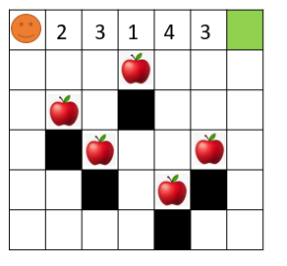

Drop

Go down

Pick up

Go down

Repeat< value on cell> times

Set <my number> to <value on cell>

Go right

Go up

Repeat< value on cell> times

Go up

EXERCISE 5:

|  |  |
| --- | --- |
| Objective | Pick up all apples!!!  **Warning: your code shall work for the 2 cases!!!!** |
| Maximum number of instructions | 12 |
| Allowed instructions | IF <CONDITION> GO-RIGHT PICK-UP GO-DOWN GO-UP  REPEAT < > TIMES WHILE <CONDITION>  WRITE < > SET <MY-NUMBER>TO< >  INCREMENT<MY-NUMBER> OF < > <MY-NUMBER> |
| Allowed conditions | <HAS CELL ON LEFT> <HAS APPLE>  <HAS CELL ON RIGHT> |

**CASE 1 : CASE 2:**

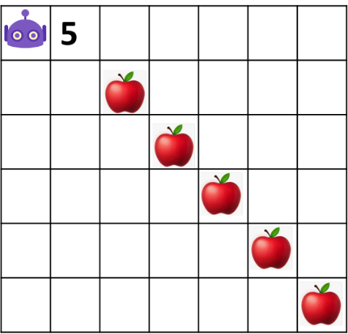 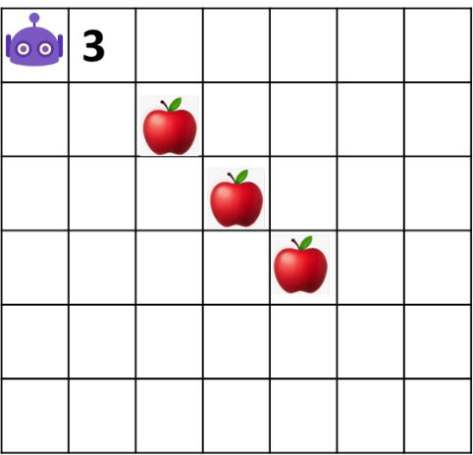

Pick up

Go right

Go down

Go right

Repeat <value on cell> times

Set <my number> to the <value on cell>